MODULE 3

**1.** Identify all duplicate cases using **prof**. Using all observations, find the average and standard deviation for **age**. Repeat the analysis by first filtering the data set to include one observation for each instructor with a total number of observations restricted to 94.

|  |  |  |  |  |  |
| --- | --- | --- | --- | --- | --- |
| **Indicator of each last matching case as Primary** | | | | | |
|  | | Frequency | Percent | Valid Percent | Cumulative Percent |
| Valid | Duplicate Case | 369 | 79.7 | 79.7 | 79.7 |
| Primary Case | 94 | 20.3 | 20.3 | 100.0 |
| Total | 463 | 100.0 | 100.0 |  |

|  |  |  |  |
| --- | --- | --- | --- |
| **Descriptive Statistics** | | | |
|  | N | Mean | Std. Deviation |
| age | 463 | 48.37 | 9.803 |
| Valid N (listwise) | 463 |  |  |

Before removing the Duplicate Cases

|  |  |  |  |
| --- | --- | --- | --- |
| **Descriptive Statistics** | | | |
|  | N | Mean | Std. Deviation |
| age | 94 | 47.55 | 10.257 |
| Valid N (listwise) | 94 |  |  |
|  |  |  |  |

**2.** Using a bar chart, demonstrate if instructors teaching **lower division** courses receive higher average teaching evaluations.

“Yes, instructors teaching lower division courses receive higher average teaching evaluations.”

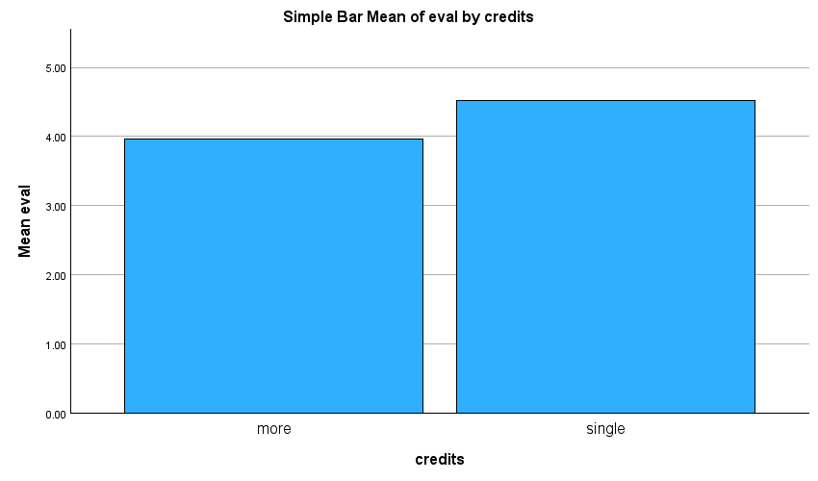

**3.** Using **gender** differentiated scatter plots, plot the relationship between **age** and **eval**.

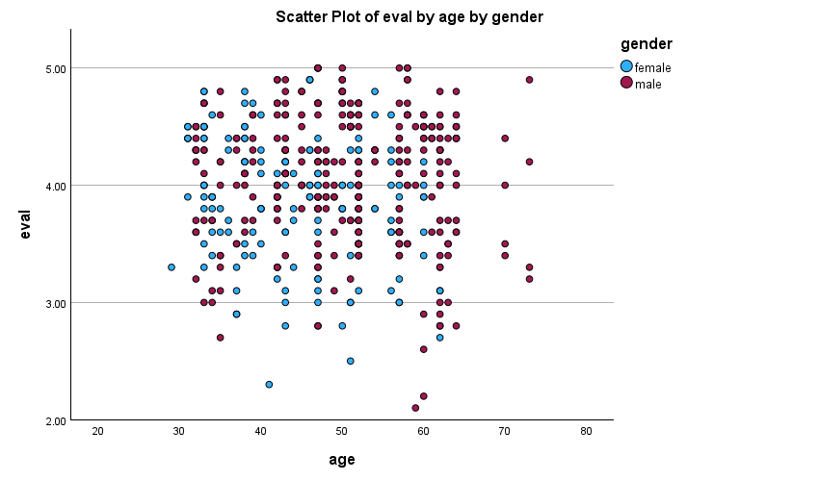

**4.** Differentiated by **credits**, create a box plot for **beauty**.

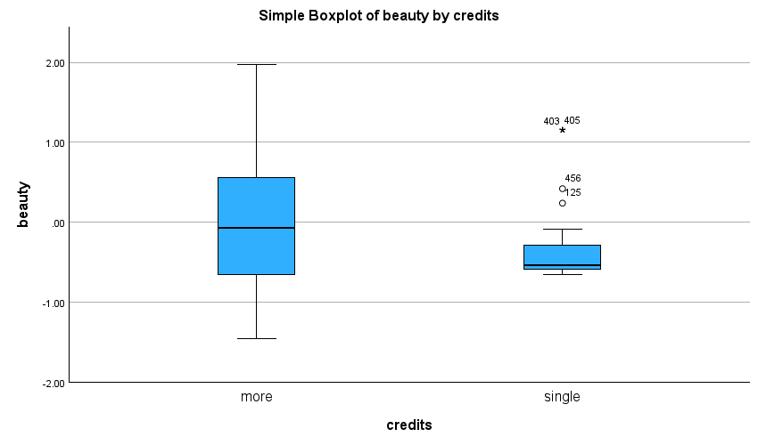

**5.** Using OLAP cubes reproduce the following table.

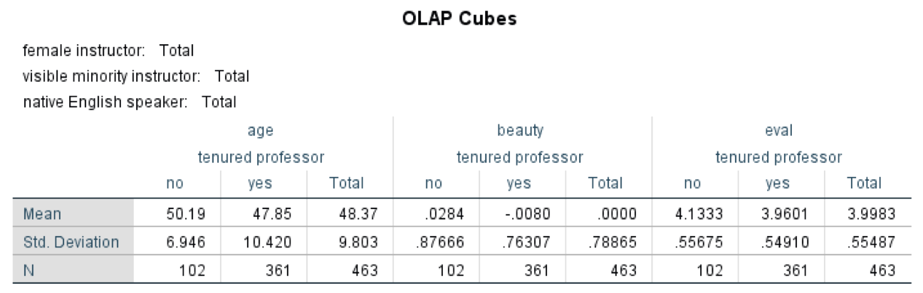

|  |  |  |  |  |  |  |
| --- | --- | --- | --- | --- | --- | --- |
| **Case Processing Summary** | | | | | | |
|  | Cases | | | | | |
| Included | | Excluded | | Total | |
| N | Percent | N | Percent | N | Percent |
| age * tenure * tenured professor | 463 | 100.0% | 0 | 0.0% | 463 | 100.0% |
| beauty * tenure * tenured professor | 463 | 100.0% | 0 | 0.0% | 463 | 100.0% |
| eval * tenure * tenured professor | 463 | 100.0% | 0 | 0.0% | 463 | 100.0% |

|  |  |  |  |
| --- | --- | --- | --- |
| **OLAP Cubes** | | | |
| tenure: Total | | | |
| tenured professor: Total | | | |
|  | N | Mean | Std. Deviation |
| age | 463 | 48.37 | 9.803 |
| beauty | 463 | .0000 | .78865 |
| eval | 463 | 3.9983 | .55487 |

**6.** Is there a systematic relationship between **gender** and **division**? Produce a cross tabulation between the two with percentages to answer this question.

|  |  |  |  |  |  |
| --- | --- | --- | --- | --- | --- |
| **gender * division Crosstabulation** | | | | | |
|  | | | division | | Total |
| lower | upper |
| gender | female | Count | 60 | 135 | 195 |
| % within gender | 30.8% | 69.2% | 100.0% |
| % within division | 38.2% | 44.1% | 42.1% |
| male | Count | 97 | 171 | 268 |
| % within gender | 36.2% | 63.8% | 100.0% |
| % within division | 61.8% | 55.9% | 57.9% |
| Total | | Count | 157 | 306 | 463 |
| % within gender | 33.9% | 66.1% | 100.0% |
| % within division | 100.0% | 100.0% | 100.0% |

**7.** Are **beauty** and **age** correlated? Using Pearson Correlation to answer this question.

|  |  |  |  |
| --- | --- | --- | --- |
| **Correlations** | | | |
|  | | age | beauty |
| age | Pearson Correlation | 1 | -.298** |
| Sig. (2-tailed) |  | <.001 |
| N | 463 | 463 |
| beauty | Pearson Correlation | -.298** | 1 |
| Sig. (2-tailed) | <.001 |  |
| N | 463 | 463 |
| **. Correlation is significant at the 0.01 level (2-tailed). | | | |